

Digital Menu Application For Accessibility In Restaurants

Final Year Project Report

DT282

BSc in Computer Science International

### Angela Peng

### Oisin Creaner

### School of Computing

### Dublin Institute of Technology

### <Date>



Abstract

Declaration

I hereby declare that the work described in this dissertation is, except where otherwise stated, entirely my own work and has not been submitted as an exercise for a degree at this or any other university.

Signed:

_________________________

<Student Name>

<Date>

Acknowledgements

Body text

Table of Contents

1. Introduction
   1. Project Background

The aim of this project is to assist individuals and businesses with flexible communication in the workplace. Ordering food through an application can be of great efficiency for both users and businesses with the aid of technology. This application can assist users that may have anxiety in social environments to feel comfortable and enjoy their time at a restaurant without the need to interact directly with a waiter. The real-time notification interaction between users and business provides a firm bridge of communication. Kitchen staff that can see orders placed are able to determine when the order is available to be served, this can be of great advantage to both customer and staff. The data from orders allows customers to keep on track of time and allows staff members to manage their business. This project will consider many ways of user accessibility in design, implementation and development. A key feature to this project for efficiency is the use of QR codes. QR codes or also known as Quick Response codes have existed for over 15 years. Quick Response codes were first introduced by Denso Wave during 1994. It was used to enhance decoding speed and the ability to hold large amount of information. QR codes not only has the function of holding data but it is also a great marketing tool to draw in tech savvy audiences.

Internationalisation is a problem we face on a daily basis, with the aid of technology we are able to break that language barrier. By implementing a language setting into this application, we are giving a chance to open up the many possibilities of internationalisation. Allowing multiple languages can be of great benefit to broaden the business into the global market.

* 1. Project Description

This project will be divided into three parts, Client, Server and Administrator. A diagram shown below a summary explanation of the overall application. Client application uses many API libraries to perform tasks such as reading QR code, make order, make payments through the application and receive live updates on order status. Server application will be able to manage order status and restaurant menus.



* 1. Project Challenges

There were many challenges faced during the development of this project. Below are some of the major challenges and issues that were encountered.

#### Appropriate API Libraries

Choosing a precise API for certain functionality was a challenge as there are both pros and cons that needs to be considered. While choosing a third-party barcode scanner there where many libraries to choose from. Google Mobile Vision and ZXing barcode scanner were the top two APIs that were examined for this project. At the end ZXing API was chosen because of its simplicity in use compared with google vision.

#### Firebase Backend

With a lack of knowledge on firebase, going back and forth between different backend services slowed down a significant amount of time in the development phase. This caused a great challenge. But with determination of producing real-time data and notification services, Firebase was the best service to implement.

#### Accessible User Interface Design

To implement a user-friendly interface that is accessible to users with colour blindness, choosing a colour palette was a great difficulty. Considering the different types of colour blindness and its statistics, deuteranomaly is one of the most popular kind which is a reduced sensitivity to green light. Research shows that one in twelve men are colour blind. After testing out different colour combinations with a colour blind tool a simple solution is to set the contrast of colours and text to a 4.5:1 ratio.

* 1. Project Objectives

The main objective of this project is to create an interactive order management system with the aid of QR codes. By using QR codes we are able to retrieve data efficiently from our backend firebase. Not only is this project focuses on the use of QR code but also allow users to integrate different languages whether for educational purposes or translation purposes. This application has the ability to implement different languages

* 1. Structure of The Document

#### Chapter 2 – Research

In this section,

#### Chapter 3 – Design

In chapter 3,

#### Chapter 4 – Architecture & Development

This section,

#### Chapter 5 – System Validation

Testing will be conducted

#### Chapter 6 – Project Plan

Project plan

#### Chapter 7 – Conclusion

Conclude

1. Research
   1. Background Research

For a business, it is important to understand its market and acknowledge the connection with its consumers. Flexibly is the key to a successful business, by implementing technology into the food and drink industry we are able to establish this connection. An application that captures user detail and functions subjected to flexibility like diary free, gluten free, vegetarian or vegan. We can build a trusted foundation between the producer and consumer.

Point of Sale (POS) systems contains tools that are essential to businesses that handles sales reporting, customer management, Inventory management and employee management. POS can provide store manager with information that increases business efficiency.

* 1. Similar Technologies

#### Order Wizard

#### 

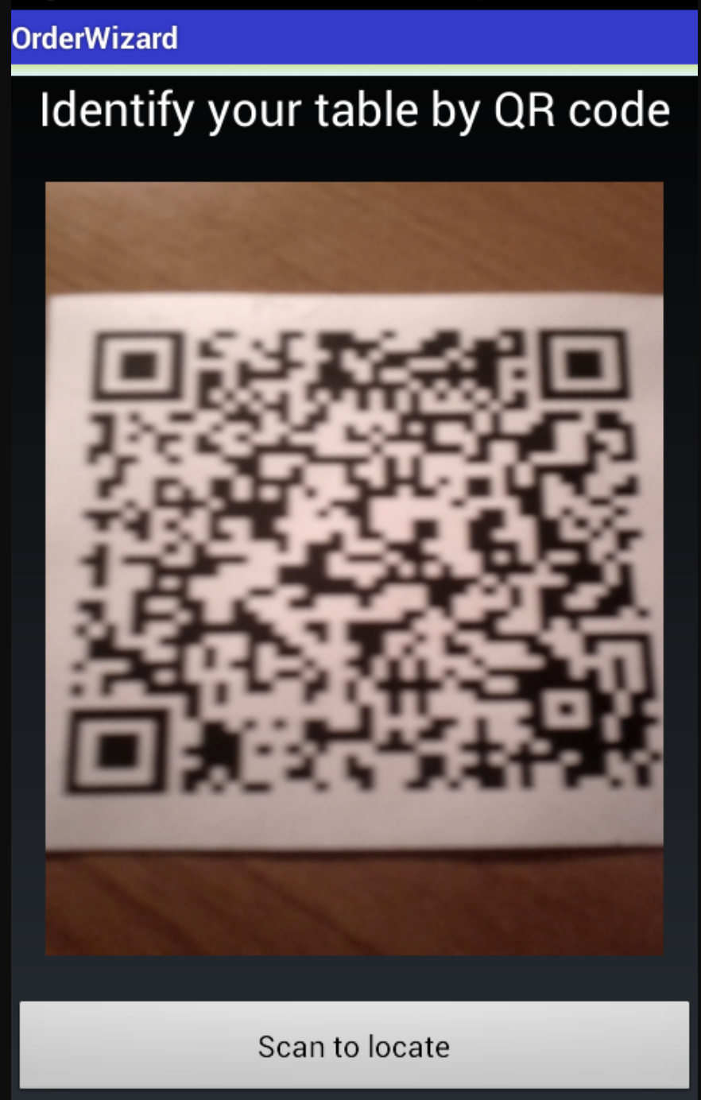 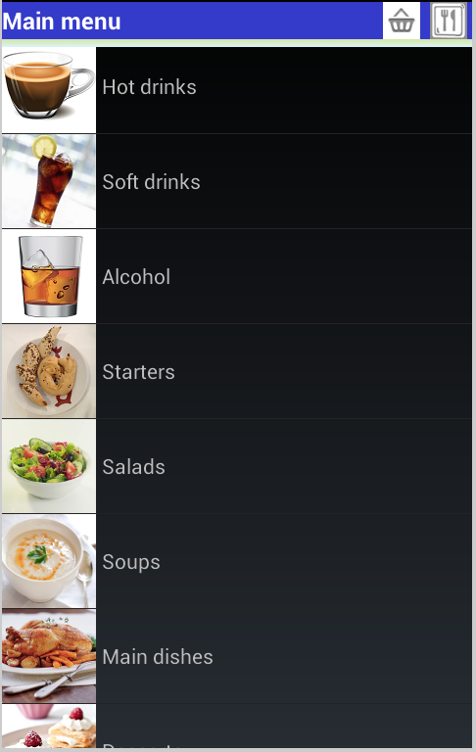

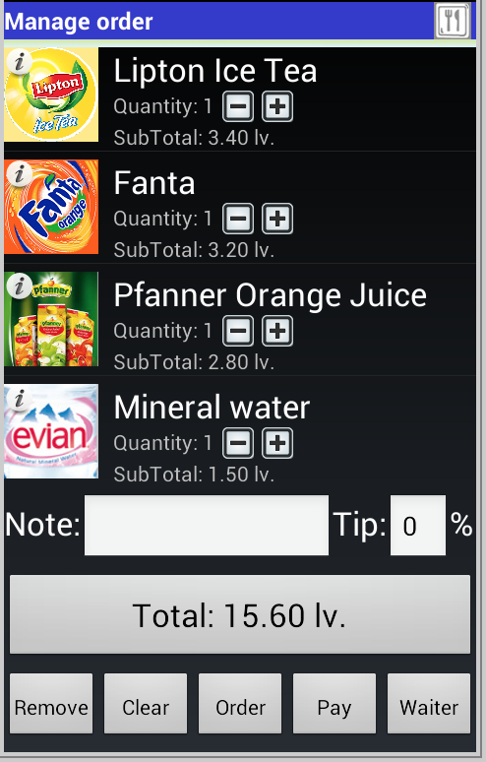 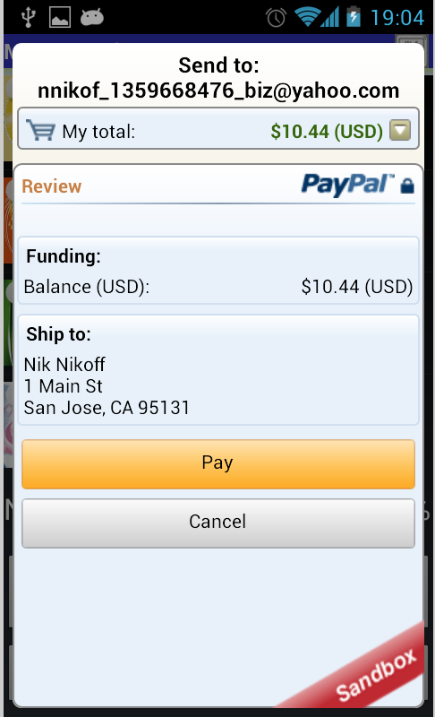

Order Wizard has similar functions to this project including QR code scanning and processing payments through the application. This application supports both android and IOS system. The system will ask the user to scan a QR code to retrieve a restaurant, then depending on the restaurant a menu will display. From the menu, the user is able to add items to order, when they are finished they can then edit, delete or add extra details. Payments are compensated by PayPal, offline cash or offline card transaction.

A benefit that this application take is users can call the waiter if they want to process the transaction with cash.

A disadvantage is that any extra details that the user adds is not by item but by the overall order. This application also does not ask for customer details this may cost a loss in clientele and security breach. User authentication provides secure transactions and personal information without this it becomes a vulnerability. The system will become exposed to cybercriminals from gaining personal information.

This application is available on google play but there haven’t been any updates since 2013 when the application was first created. The overall UI appearance is also out dated with a harsh black background and little creativity in design.

#### 2.2.2 eHopper POS

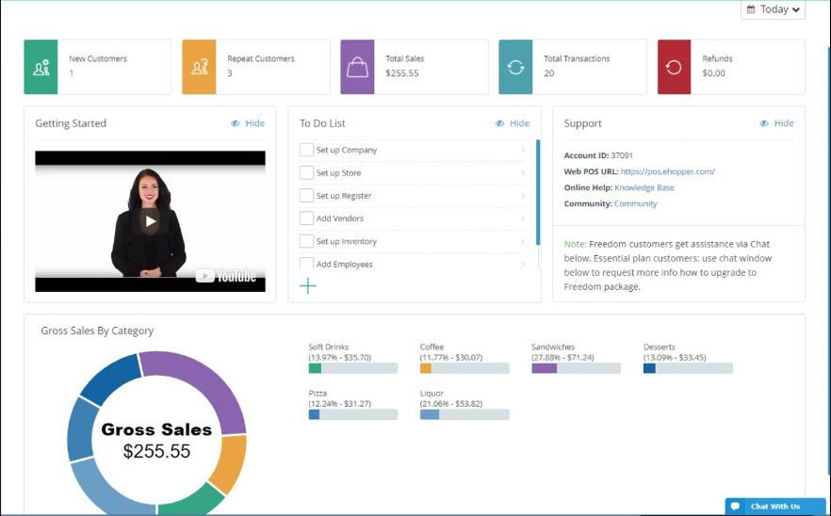

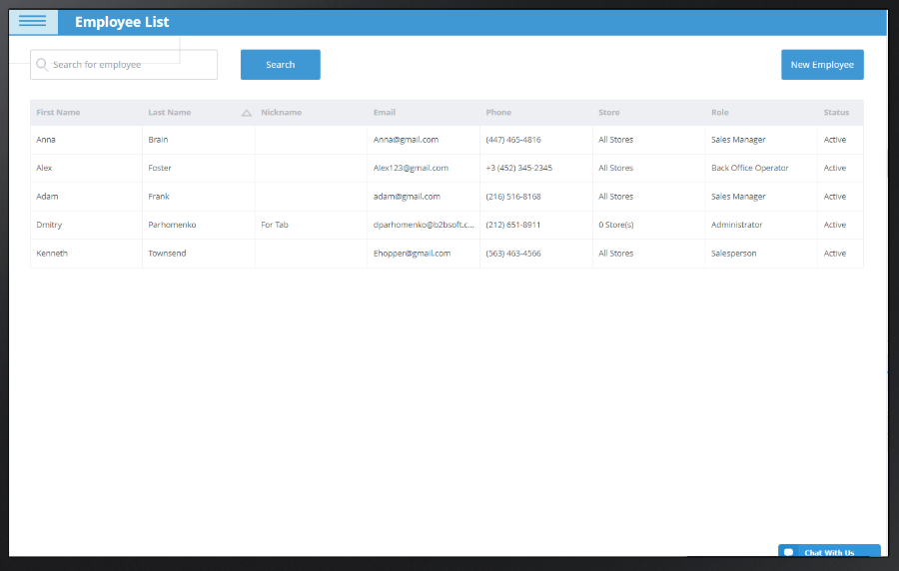

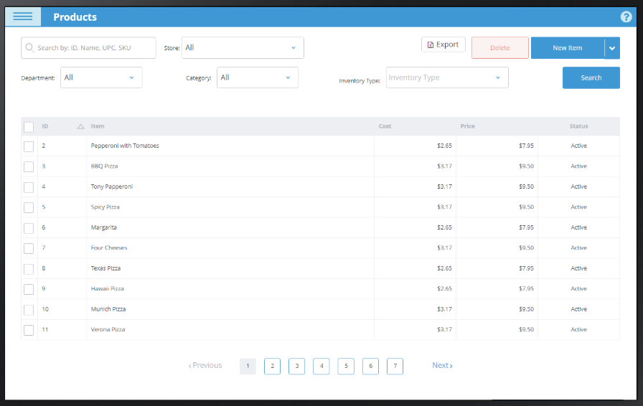

eHopper is a point of sale management system. This program is available in IOS, android and windows operating systems. According to their webpage and documentation this system possesses many operations from Multi-store management, POS reports, employee management, order tracking to tax management and ingredient management. While this software is not exactly similar to this project taking inspiration from this idea a server application was developed for restaurant management.

An advantage of this POS is it provides the business with an extensive amount of functions to manage their performance. The system supports many devices and it provides a self-explanatory user interface.

A disadvantage of eHopper is that for a business to access its full potential, expenditure of the system increases.

2.3 Technologies Researched

#### 2.3.2 Front End Development (Native, Web, Hybrid)

Developing a front-end user interface, I considered the use of native, web and hybrid application. Below discusses its pros and cons of utilizing these three types of front-end development.

As this project is concerning the development of an android application, android API’s native contains many tools that can be directly accessed through the IDE. For android studio, it be dependent on XML files for activities. Fast and responsive. As the application is native to its platform, data is fetched from a web server rather the application. Internet access is not an essential requirement, though some application do expect to use it. Specific UI design for an overall better user experience. More interactive experience because they are running on the device built-in features. Runs much smoother for user input and output. Need an extensive amount of knowledge in the programming language during development and maintenance. Native apps need constant software updates to fix any bugs. Needs vast amount of time to implement with the large amount of work that is expected to develop a native application the cost sequentially increases

Web application hosted by web browsers are condensed information from the website to produce a more functional application. A wide range of technologies can be used to implement a web application this includes, open source platforms like PHP or MYSQL. Easy to maintain without user having to constantly update the application. Accessible to all platforms through an internet connection which allows cross-platform application service. Security is a priority in web applications. Unlike other simple websites, web applications are utilized on the machines dedicated server. Needs internet access at all time, without it users cannot experience the application to its full potential. Much slower than native apps. Less interactive for client side.

Hybrid applications is a combination of a native app and a web app. Built using JavaScript, HTML, CSS wrapper in a native container like, web view. Easy to develop and time for development is significantly faster than native apps. Allows access to different device platforms to be integrated this is cost efficient. Consistent maintenance can be done without having the user update the application expect for any major changes. Much slower than native apps. Less interactive, navigation to different activity could be lagged. Cannot experience access to native features, this can be a downfall for UI design and programmatic operations.

#### Back End Research (Firebase, PHP, SQLite)

Cloud hosted services which can used by application development as a backend server. Firebase offers many abilities to perform client-server interaction. Offers storing and synchronising real time data to any connected devices of all platform. Offers the use of google analytics. Easy to implement with little back end development. Can implement many ways to authenticate users including email and password, Facebook, google account authentication. Making developing apps identifying users efficiently. Allows notifications to be sent to targeted users using the notification console GUI. This is a free service that firebase provides. Usage limitations, firebase free version only allows up to 50 connections. Doesn’t work like ordinary relational DBMS. Therefore, normal SQL queries are no use in firebase

SQLite is an open source database service and it can be accessed using android studio IDE. No installation is required for this database service because it is an in-process relational DBMS. Lightweight structured file using query language, SQL to retrieve data. Doesn’t rely on server which means no configuration is required and can be portable. Communicates directly with the application for this instance Android studio IDE. Can only handle low to medium traffic which is not suitable for large data storing application. Scalability limitations

#### 2.3.4 Application Programming Interface and Libraries

With the introduction of google play service 7.8, Mobile vision API released a new API which enables barcode scanner to read and decode its contents. Google barcode API is able to detect barcodes in real time on devices in any orientation. Implementing this with permission to use Camera API, an android framework which supports various camera features. Allows the application to access the device camera and scanning any barcode it detects.

ZXing also known as “Zebra Crossing” is a google operated open source service which is used to read and decode barcodes using an image processing library.

#### 2.3.5 Customer Relationship Management (CRM)

Mobile customer relationship management (CRM) is extremely important in today’s business industry. With the increase in the use of technology and internet services businesses ensures customers are receiving the best service at all time. Capturing client details allows employees to provide real-time data and information to clients immediately.

Benefits of customer relationship management is its ability to deliver performance reports, analytics in sales and organizational activities in businesses.

#### 2.3.6 Localizing User Interface

Advancement of technology made it possible to communicate with individuals of different nationality to interact with each other at ease. For instance, if a user that has many allergies is travelling and ordering food in a foreign restaurant becomes a difficulty an application that supports different languages can benefit these individuals. Therefore, the language barrier is not a problem when customers go to a non-English spoken country.

Android studio is able to localize the user interface to support different languages. By utilising translation editor in the IDE, it will allow the application to change from one language to another and not effecting the systems default language.

#### 2.3.7 PayPal

The most secure way of electronic transactions is through PayPal. PayPal released BrainTree in 2014 making it effortless to develop payment services on Android, IOS and web platforms. BrainTree accepts payments using credit card, PayPal, Google Pay and Apple Pay. By using HTTP based RESTFUL APIs, we can retrieve real-time data to authenticate credentials. Responses and requests are structured in JSON.

#### 2.3.8 Vision Impairment

There is an estimate of 285 million people globally who are vision impaired. Developing an application that allows flexibility and change in user interface can ease any conflict and intimidation for individuals with vision impairment.

Colour schemes, amount of information displayed and navigation should all be considered when developing.

1. Design
   1. Methodology

AGILE METHODOLOGY

* 1. Technical Architecture Design

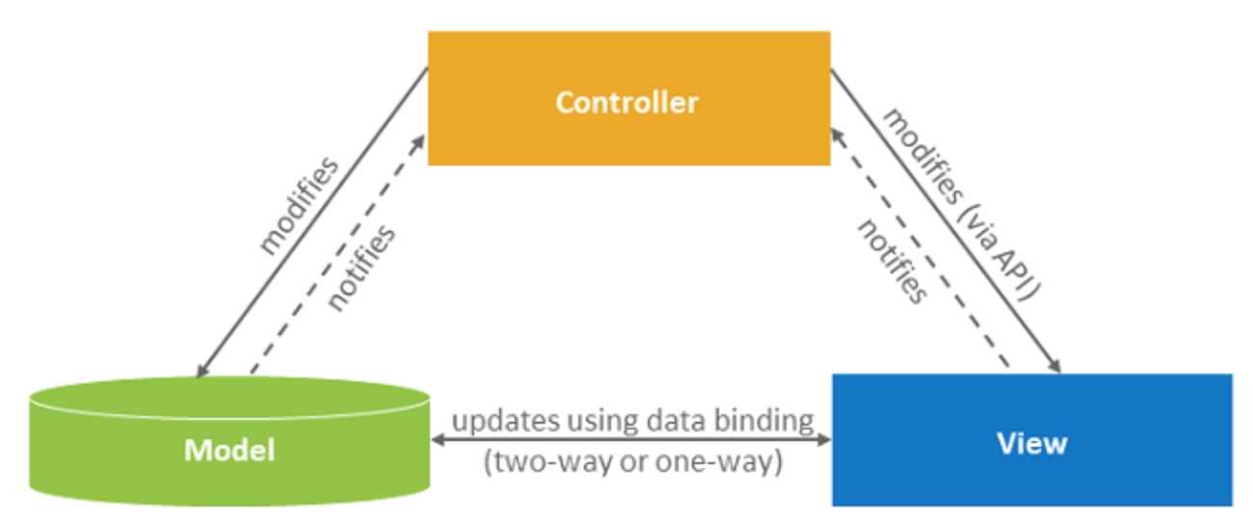

The model view controller architecture (MVC) assisted me to design an interactive system that can be flexible to change. MVC consists of three parts, the first would be the model, this contains the data of the application any changes made to the model correspondingly changes the view to show the user of a new update. The second part is the view, this is the user interface displayed to the user. The last part is the controller, this controls the user input and according to the inputs the view and/or model might changes.

From this architecture, I am able to design my system which will consist of the customer (view), the manager (view), database(model). The controller will update any data that has been changed by both views to model, once the update is done the views will automatically update. With the three environments working together it creates a smooth application.

* 1. Use Case and Iterations

This section comprises of use case diagrams, sequence diagrams and their corresponding iterations. I think that this is a simple way to understand each actors’ roles and what the system entails in a sequential order.

#### 3.3.1 The First Iteration

The first iteration includes actions customers are able to perform when using this application. The process of customer upon registering and making an order will involve at least 2 actors, the customer itself and the restaurant staff.

Main Flow

* Customer Creates Account
* Customer allows application to access device camera to scan QR code
* Customer can view menu
* Customer makes order
* Customer can view status of their order
* Waiter can view order status
* Manager can view menu

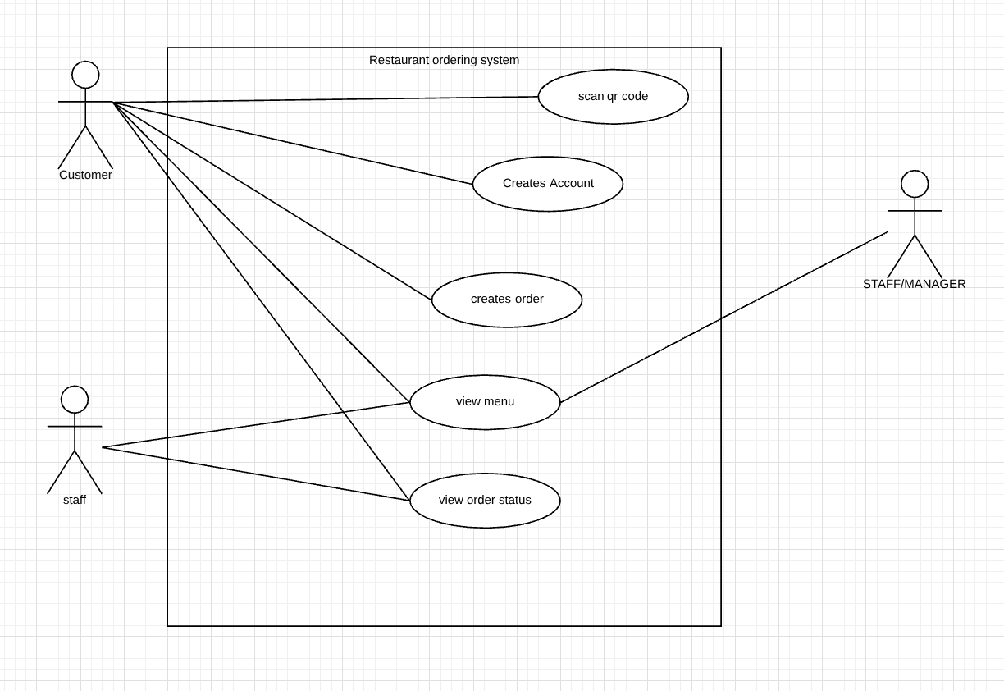

Description: From the first iteration, we can see that the Customer is able to scan QR, create account, create order, view menu and view order status. The staff actor is consisting of waiters and chefs.

Pre-condition: we know nothing about the user.

Post-conditions: we know information about the user, we know their allergies and we know if they have a vision impairment.

Exception Errors: The user may only use card transaction when using this application.

Alternative variations: Users are validated by unique email and a corresponding password.

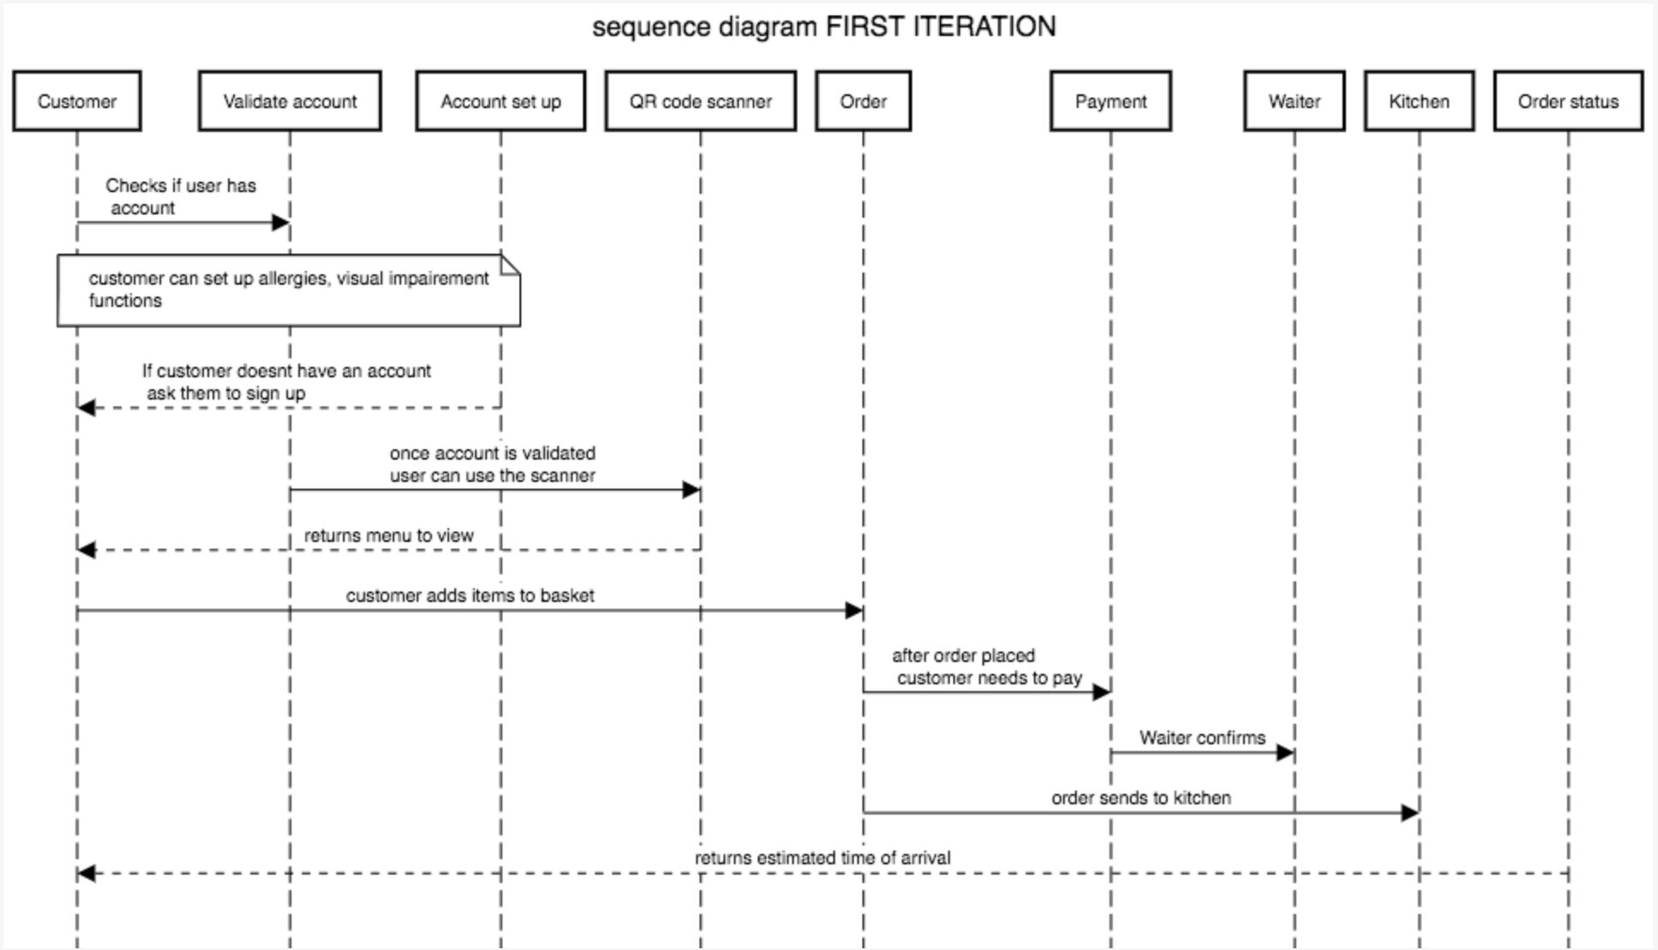

This sequence diagram shows the sequence of actions performed by the customer when using this system. The user upon using the application must log into an already existing account or create a new account. The user inputs will be validated based on firebase authentication on email and password. Once the user is able to access their account they are able to use the QR code scanner. They must first allow the application access to their mobile device camera to perform the camera function. After scanning the QR code, the activity page will show the restaurant menu from here the user can add items on the menu into their basket to add to the order. Once the user is finished with their order they must pay the total amount that is owed before the order goes to the kitchen. The application will ask the user permission to enter card details. Subsequently, the transaction is successful order will be sent to the kitchen staff and waiter. The user from here will be able to see the estimated time of arrival to their table.

#### 3.3.2 The Second Iteration

Second iteration is the actions performed by waiter/kitchen staff actor. They have limited access to information about the restaurant itself and customers. Another actor that is involved in the second iteration is the administrator. Administrators has unlimited access, they would know a certain amount of knowledge regarding how the system works and are able to perform maintenance and updates to the software when needed.

Main Flow:

* Staff depending on their role a waiter can view transaction and order
* Kitchen staff can view order only
* Administrator performs system maintenance

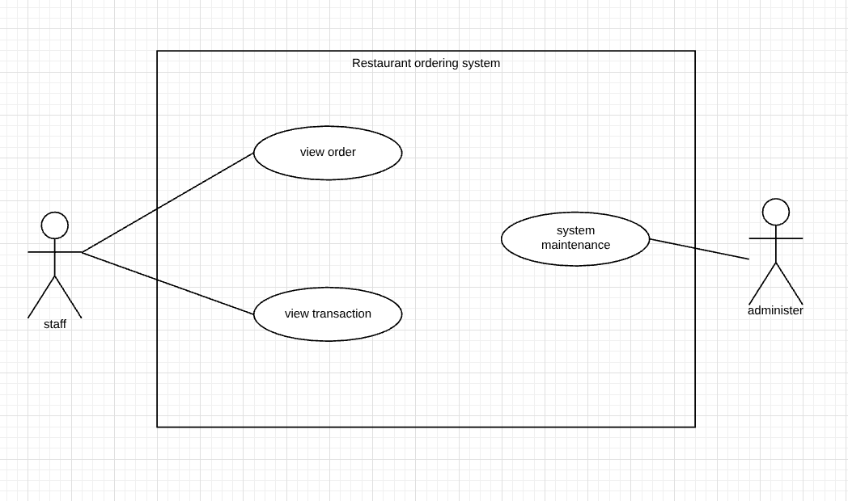

Description: The second iteration shows the staff and administrator. The staff can see the order placed by customers and transaction progress. Administrators maintains the system and keeps the system updated.

Pre-condition: Each staff are given roles by manager, we know information about each staff. We know information about the administrator. Staff doesn’t know customer orders.

Post-condition: Waiters are able to see order after customer has placed one.

Exception Error: The chef can only see the order if the transaction process is completed.

Alternative Variables: Waiter and chef must log into the staff account, role and position is saved.

#### 3.3.3 The Third Iteration

The third iterations involve the manager of the restaurant only. They also have unlimited access to information about everything in the business. They are able to perform the CRUD operations to menu items, manage employees, manages stocks and review analytic reports. The manager runs the restaurant therefore, have the ability to control the environment.

Main Flow:

* Managers can add new items to the menu
* Managers can delete items from the menu
* Managers can edit items on the menu
* Managers can view sales analytics/reports
* Managers manages stock
* Managers manages staff

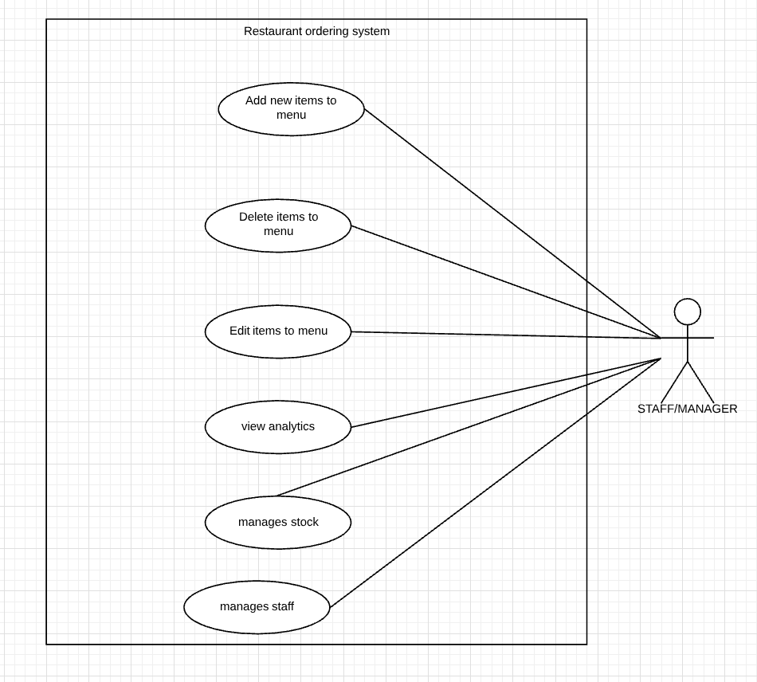

Description: The third iteration will contain the details of roles the restaurant manager. The manager can create, view, update and delete menu items. Managers are also responsible for staff management and stock management. By capturing customer details in the first iteration managers can view weekly, monthly and annually analytics of target sales.

Pre-condition: Managers knows information about menu, staff and products.

Post-condition: Managers can view targets and what products needs to be ordered.

Exceptional Errors: Manager is the only one who can view the analytics

Alternative Variables: Manager logs into staff page, the role and position must be clearly stated

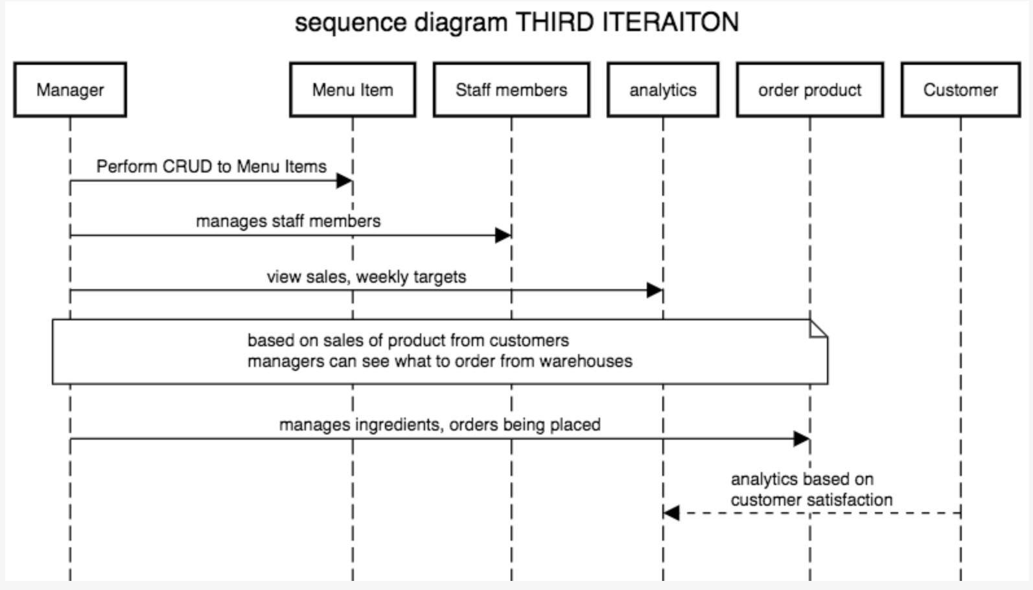

Managers can perform create, read, update and delete (CRUD) operations on menu items. Managers can manage staff members by adding new employees and organizing roster. Based on customer data and sales transactions manager can see weekly/monthly reports which will let manager learn how much stock needs to be ordered. Managers are the only actors that can access this information.